Current Excel Workflow
As of June 24, 2026

Two Spreadsheets
- CAGR.XLSM
- snapshot.xlsm

CAGR
This is the Trading Journal that holds a record of every trade ever made, including FCX_20:
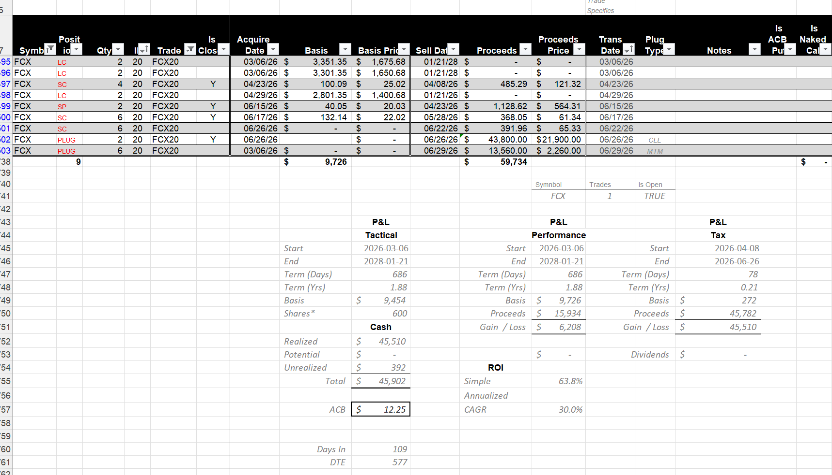
The are currently 6737 records as I write this. Search/Filtering is accomplished via VBA code behind a custom ribbon:
